Animals of the Pauatahanui Inlet

2b: Pita Pukeko
Do you know what a pukeko is? Have you seen a pukeko?

Here is Pita Pukeko. He has beautiful blue feathers, with a red beak and orangy legs and feet. He lives in the grasses around the Pauatahanui Inlet and he is a very cheeky boy.  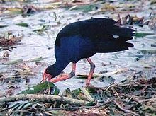  When Pita gets hungry he knows there will be lots of tasty food around the Inlet. He could choose to eat grass, caterpillars, insects, or even small frogs.  Pita builds his nest in a clump of grass and stamps it down with his feet. He shares his nest with other pukeko and when his friend Polly lays her eggs in it he helps her by sitting on the eggs for a while.  If he wants to tell his friends that he has found some tasty food he calls out very loudly so they can hear him from far away. They would come running very quickly because pukeko have really strong legs. Pita and his friends also have very strong wings, so if anything frightens them they can quickly fly away. | 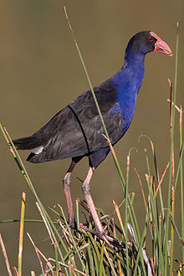  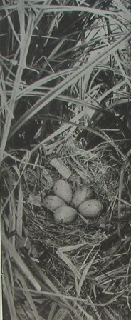  Next time you go  around the Inlet look for Pita and his friends.

Can you draw a poster about Pita Pukeko?

Here are three things that Pita likes to eat. | Pita is sitting on his nest.
Pita is talking to his friends. | Pita is flying away from a dog.

Images from http://www.nzbirds.com/birds/pukekonest.html and www.en.wikipedia.org/wiki/Pukeko

