**Animals of the Pauatahanui Inlet**

**2a: Pukeko**

**This fact sheet tells you about one of the common birds living in the Pauatahanui Inlet, the pukeko or purple swamp hen. If you visit the Inlet you may be able to find and observe some of these interesting birds.**

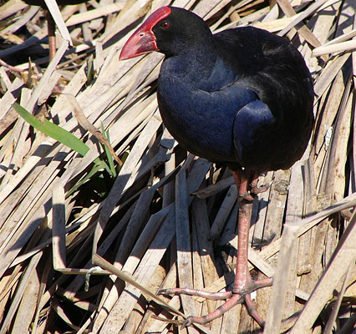Many people get confused when they think about pukeko. On the one hand, this pretty bird is a symbol of New Zealand nearly as well known as the kiwi. Pukeko garden ornaments are found all over the country, and you will also find pukeko printed on tea towels and cards and represented in jewellery. The birds can be seen on many of the nation’s roadsides, and have even featured in TV advertisements, so most New Zealanders are familiar with them. However, not everyone thinks that they are cute and good to watch, because sometimes they move into farmland where they can wreck pasture and crops. They can also eat eggs, baby birds and frogs, and sometimes strip gardens of newly planted shrubs and trees.

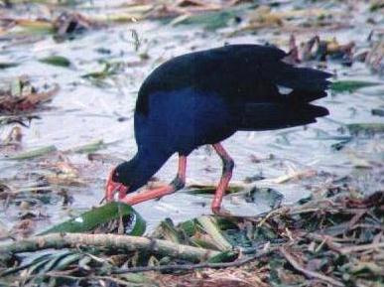

Pukeko are mostly vegetarian, and they strip seeds from plants, bite off shoots and dig up roots with their strong beaks. The pukeko stalks more animal food after the breeding season because the chicks mainly eat flesh. When it eats, the pukeko often holds its food in one claw and then moves it into its mouth.

They usually live in wet areas near water, swamps, river banks or in estuaries like the Pauatahanui Inlet. Pukeko can swim, run and fly and their call is a very loud harsh shriek.

|  |  |
| --- | --- |
| Plumage | The pukeko has a beautiful purplish blue neck and chest, a black back, orange legs and feet and a bright red bill. It has white feathers under its tail which it displays when it is agitated. Pukeko moult in the spring and then cannot fly for a month until the new feathers grow. |

|  |  |  |
| --- | --- | --- |
| The pukeko’s nest is quite flat. It is built on the ground from grass and rushes, which the pukeko stamps down before laying its eggs. The eggs are cream with brown blotches at one end. Pukeko are really unusual birds because often six or seven will share the same nest and several females might lay their eggs there during the same breeding season. All the adult birds in the nest share the chore of sitting on the eggs. The males usually sit on the eggs at night, and when the chicks hatch all the adult birds share the care and the feeding of them. If danger strikes they can band together to frighten the intruder off. |  | Young chicks can fly when they are about 3 months old, and although pukeko are strong fliers they have trouble taking off. With their long legs dangling, they look very clumsy in flight.  Pukeko_chick  Although they can travel a long way most of them stay close to the area where they hatched. |

Many farmers and gardeners don’t like pukeko and don’t want them to multiply much, so in the duck-shooting season hunters are also able to shoot pukeko. Some years between 50,000 and 60,000 birds are shot throughout New Zealand.

**On the next page there are two activities for you to do.**

**ACTIVITY ONE**

What do you think about the pukeko? Is it a special New Zealand bird that we should be proud of, or is it a pest? Divide your page into two. In one space write some evidence and ideas to show why people might value the pukeko. In the other space, write some ideas about why it could be a pest. Then summarise what you think about the pukeko, giving reasons. (You could do an internet search to get more information and ideas.)

**ACTIVITY TWO**

Write six true sentences about the pukeko, starting with each of the following letters.

P . . . . . . . . . . . . . . . . . . . . . . . . . . . . . . . . . . . . . . . . . . . . . . . . . . . . . . . . . . . . . . . . . . . . .

U. . . . . . . . . . . . . . . . . . . . . . . . . . . . . . . . . . . . . . . . . . . . . . . . . . . . . . . . . . . . . . . . . . . . . .

K . . . . . . . . . . . . . . . . . . . . . . . . . . . . . . . . . . . . . . . . . . . . . . . . . . . . . . . . . . . . . . . . . . . . .

E . . . . . . . . . . . . . . . . . . . . . . . . . . . . . . . . . . . . . . . . . . . . . . . . . . . . . . . . . . . . . . . . . . . . .

K . . . . . . . . . . . . . . . . . . . . . . . . . . . . . . . . . . . . . . . . . . . . . . . . . . . . . . . . . . . . . . . . . . . . .

O . . . . . . . . . . . . . . . . . . . . . . . . . . . . . . . . . . . . . . . . . . . . . . . . . . . . . . . . . . . . . . . . . . . . .

**Images**

Pukeko on flax fronds: Steven Reekie, <http://www.nhc.net.nz/index/birds-new-zealand/Pukekoe/Pukeko.htm>

Pukeko feeding: [www.en.wikipedia.org/wiki/Pukeko](http://en.wikipedia.org/wiki/Pukeko)

Pukeko's plumage: Dr Kerry Rodgers, on <http://www.tiritirimatangi.org.nz/fauna/pukeko.htm>

Pukeko chick: Floyd Wilde, <http://en.wikipedia.org/wiki/File:Porphyrio_porphyrio_melanotus_juvenile.jpg>