Animals of the Pāuatahanui Inlet

1: Tunnelling mud crabs

This fact sheet will give you some information about one of the common crabs that live in the Pāuatahanui Inlet. If you visit the inlet you will be able to find and observe some of these interesting creatures.

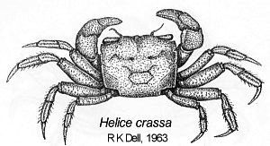
What does it look like?

The tunnelling mud crab has a back that is square in shape, and when fully grown the crab measures 4cm across. It has hairless legs and its eyes are on short brown stalks. Young crabs are tawny brown and turn green to yellow as they get older.

The crabs live for an average of five to six years, but sometimes they can live as long as 10 years.

The tunnelling mud crab’s scientific name is Helice crassa.

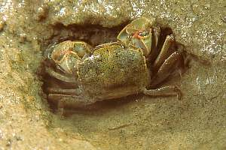

Note the square shape of the back.

Where do tunnelling mud crabs live?

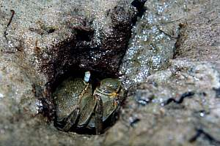
The crabs are found in a burrow or tunnel that they make in the mud at the high tide level. They sleep in their burrows at night and often plug the end of the burrow with mud to keep out intruders. During the day they return often to their burrows to wet their gills. Their burrows usually have more than one entrance and can include a complex set of tunnels. The crab holes are 10 to 15mm across and slant downwards into the mud. In the photo, you can see a crab at the entrance to its burrow.

Sometimes a crab’s tunnels join up with the burrows of other tunnelling mud crabs.

What are the crab’s eating habits?

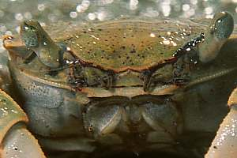
The tunnelling mud crab eats tiny living organisms—diatoms, algae and bacteria—from the mud. The Inlet has plenty of this food. Crabs move up to 200 metres away from their burrows when searching for food. When they want to eat they walk forwards with their flat spade-like nippers held in front of them. They scoop up the mud with their large nippers and carry it into their mouth. Inside the mouth the material is sorted into the food, which is eaten, and the mud, which the nippers wipe away. The crab prepares to eat as soon as the tide goes out by firstly cleaning around its burrow and then cleaning itself. Then it is ready for its meal.

Some other facts

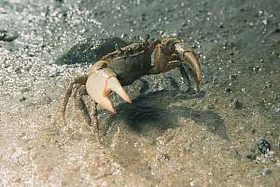
This type of crab is very wary and will scuttle and scurry away at the slightest movement. When out of the burrow it is easy prey for many of the Inlet’s birds and also for fish like flounder. It will defend the burrow against intruders and may adopt a threatening posture if it’s in danger.

Crabs mate between May and August and the female lays up to 16,000 eggs. The eggs take 42 days to incubate.

Two activities for you

- Use some of the facts that you have read about the crab to write an 8-part story board about a day in a crab’s life. Make one of your sections a drawing of the crab. To tell your crab’s story, choose some of the ideas in the oval or work out your own from the information you’ve read. | tide goes out crab sees a hungry bird  crab is hungry or tired crab lays eggs  tide comes in crab has dry gills  wants to make a new tunnel looks for food  sees another crab near its burrow
Look on the next page for your second activity.

- Write a conversation between two tunnelling mud crabs. Use what you have learnt to imagine what each crab might be thinking or wanting to do. Don’t forget to give each crab a name. You could illustrate the conversation with a scene from the inside of their burrow.

