**Animals of the Pauatahanui Inlet**

**4: Inanga (whitebait) — an endangered species**

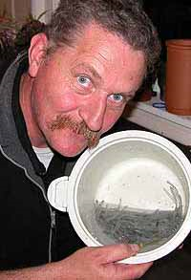In the photo, Mr Allan Burgess is holding some inanga (whitebait). If you recognised that these are whitebait, then you might be one of the lucky people who have enjoyed whitebait patties (or ‘fritters’). Mr Burgess is a whitebaiter, and he has just caught enough whitebait to make two whitebait patties for lunch. He’s got about 125 grams of whitebait, which he will mix with an egg, salt and pepper. Then he will fry the two patties, put them on buttered white bread, and eat them. Delicious!

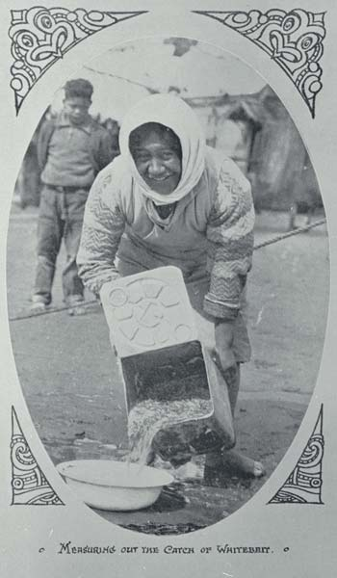

In the past, people used to catch thousands of whitebait at a time. In the picture on the left, you can see a woman tipping a whole tinful of whitebait into a basin. These days, whitebaiters can sit by a stream all day and maybe catch only two or three whitebait each time they pull the net up. All over New Zealand whitebaiters are catching fewer and fewer whitebait.

|  |
| --- |
| Whitebaiters can only catch whitebait during the ‘whitebait season’. Look closely at the two photos. What time of year do you think it is? |

**Are all whitebait the same?**

|  |  |  |
| --- | --- | --- |
| Whitebait are babies. As you can see from the 10 cent coin, they’re not very big! | Expensive delicacy | |
| Whitebait are the young (or ‘juveniles’) of native fish. But not just one kind of native fish. If you looked into a bucket of whitebait they would all look exactly the same. But did you know there could be up to five different types of fish in there? When you’re poking around in forest streams you might see some of these native adult fish. Three of them are *kokopu*, which mainly live in streams with lots of cover, such as logs and overhanging boulders. They eat invertebrates and insects that fall into the water. The other fish that start off as whitebait are *inanga* and *kōaro*. | | ***Inanga****:* This is the whitebait that is usually caught. When it grows to adulthood, it looks just like a large whitebait. They grow to about 9cm long. They usually live in lowland streams.  ***Kōaro****:* This fish is long and narrow, growing to about 16-18cm (although sometimes they grow to 30 cm). It is greenish-brown with gold blotches on it. It’s a really interesting fish because it can climb out of a bucket or aquarium. It can even climb up long waterfalls. It takes its weight on fins that have a rough surface and can climb up a wet surface a bit like a lizard.  ***Giant kokopu****:* This is a fish that can weigh up to 2 kilograms. It has green and gold markings.  ***Short-jawed kokopu****:* This is a very secretive fish and not many people have seen it. It grows to about 26cm.  ***Banded kokopu****:* This is a brownish fish with lots of pale stripes across its body. It grows to about 26cm. |

### Choose one of the native fish described above, which were all whitebait once. Can you draw and label the fish you have chosen?

|  |
| --- |
| This is a ................................................ |

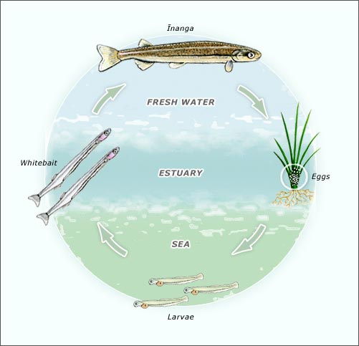

### How do whitebait live?

Native fish lay their eggs among grass on the side of a stream. They choose a spot close to where the stream runs into the sea, where the eggs will get washed by the tide. When the eggs hatch into LARVAE they are flushed into the sea on a high tide. They live for 6 months in the sea before swimming back up a river or stream. When they come back up the river they are often in large shoals, which are called RUNS. This is when whitebaiters try to catch them. The ones that are not caught grow into adults and spend the rest of their life in fresh water. They live for about a year and will SPAWN before they die.

**How are whitebait caught?**

Humans have been catching whitebait for a very long time. The early Maori caught them in flax nets supported on manuka poles. Then they cooked them in a hangi. Sometimes they dried them on a rack over a fire to preserve them.

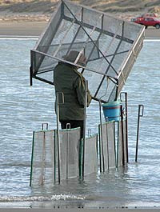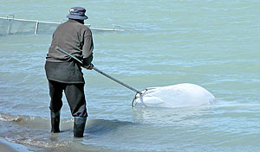These days people use four or five different kinds of net to catch them. Some are home-made but others are very sophisticated and expensive. There are rules about the size of the nets used so that no one takes too many whitebait from each run, and a net cannot stretch further than one third of the way across the stream. Whitebaiters are not allowed to block the stream to channel the fish into their net and they can only fish between 5am and 8pm during the season 15 August to 30 November. Each person is only allowed to use one net and must stay within 10 metres of the net. These rules are an attempt to stop too many whitebait being killed. Whitebait sells for about 150 dollars a kilogram (but you can make a lot of patties from a kilo!). However, there is no limit on the number of whitebait a whitebaiter can catch.

***Which picture above shows a set net? Which one shows a pole net? Use the internet to find a picture of an early Māori whitebaiting net. Can you draw it below?***

### Why are our whitebait endangered?

|  |  |
| --- | --- |
| Can you think what might threaten the whitebait in Pauatahanui Inlet? Try to think of two different things. If you’re not sure, the paragraph on the right will help you.   1. ………………………….………  ………………………….………  ………………………….……… 2. ……………………….…………  ……………………….…………  ………………………….……… | In our Inlet mud and silt are often flushed into the streams from building and construction sites and from erosion of farmland. This not only disturbs the bottom of the estuary, but it can also destroy the stream bank area where the adult fish must lay their eggs.  Much NZ seafood has a legal limit on how much can be caught at any one time, but there is no limit for whitebait. Many people believe that this is wrong, because although it is fine for recreational fishermen to catch enough for a family dinner, commercial fishers on the west coast of the South Island have been known to take hundreds of kilograms at a time. As some of the five species are endangered, taking so many at one time is not helping to increase the numbers of adult fish. |

***Can you match the words with the meanings?***

|  |  |  |  |  |
| --- | --- | --- | --- | --- |
| a | spawn |  | 1 | a whitebait that can climb |
| b | endangered species |  | 2 | the most common whitebait caught |
| c | larvae |  | 3 | where Māori cooked their whitebait |
| d | run |  | 4 | a mass of eggs laid in the water |
| e | hangi |  | 5 | the pre-adult stage |
| f | kōaro |  | 6 | sand or silt on the Inlet bottom |
| g | fresh water |  | 7 | a whitebait that can climb |
| h | estuary |  | 8 | baby whitebait |
| i | sediment |  | 9 | water that is not salty |
| j | inanga |  | 10 | a creature in danger of dying out |
| k | juvenile |  | 11 | where the river meets the sea |

***Poster activity***

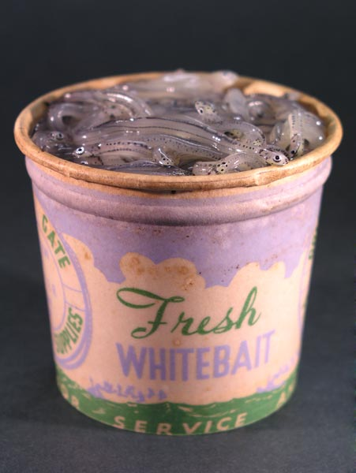Design a poster showing the rules about whitebaiting.

*Or*

Design a poster for an advertisement for a shop to advertise whitebait for sale. You can copy this picture of a ‘pottle’ of whitebait, you can find pictures on the internet, or you can draw your own.

***Write a recipe for FOUR whitebait patties.***

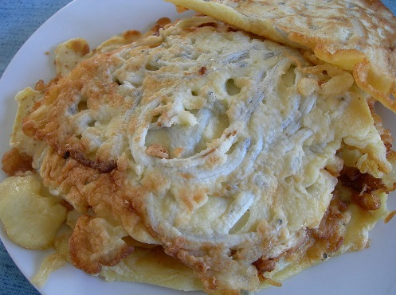

|  |  |
| --- | --- |
| INGREDIENTS (what you need) | METHOD (what you do) |

Our thanks to Mr Allan Burgess, Christchurch, for permission to use the photo of himself and the photos of the set net and pole net. See <http://www.fishingmag.co.nz/whitebait-methods.htm>. Lifecycle diagram from <http://www.teara.govt.nz/en/whitebait-and-whitebaiting/1/1>, artwork by Bruce Mahalski. Counting the catch: acknowledgement to Christchurch City Libraries; Photo of whitebait fritter from <http://upload.wikimedia.org/wikipedia/en/2/2c/Whitebait_Fritter.JPG>. Acknowledgements to the Department of Conservation and NIWA.