|  |  |  |
| --- | --- | --- |
| Something to do 1: on the map | | |
| How many of these places can you mark on the Inlet map below? | 1. Paremata bridge 2. The wildlife reserve 3. The water ski club 4. Stout cottage 5. Pauatahanui village 6. Horokiri stream | 1. Gray’s Road 2. Duck Creek 3. Motukaraka Point 4. SH 58 5. Brown’s Bay 6. Pauatahanui stream |
| Can you mark any other places on the map?  What places will you see on your Inlet visit?  You can check your map against the answers on the next page. | | |

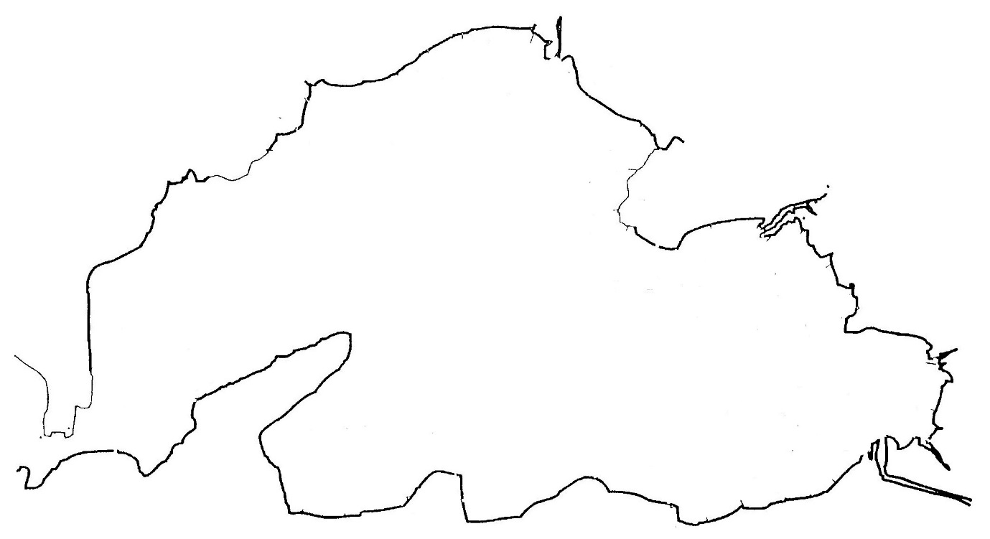

N

See if you managed to put everything in the right place.

|  |  |  |
| --- | --- | --- |
| Gray’s Road is the road on this side of the Inlet    Water ski club Motukaraka Point   |  |  | | --- | --- | | Inlet map | Horokiri stream  Wildlife reserve  Pauatahanui village  Stout cottage |   Paremata Brown’s Bay Duck  bridge Creek  Pauatahanui Stream  SH58 is the road on this side of the Inlet  Maybe you also marked in some of the other streams, St Alban’s church, the cemetery, Pauatahanui School and the Lighthouse Cinema. |