|  |
| --- |
| Something to do 4: animal tracks on the shore |
| Animals make tracks that relate to the shapes of their bodies, how they move, how they eat, and other aspects of their lives. If you are a careful observer, you can find different tracks and signs on the sands and muds and learn more about the animals that made them. Look carefully and try to answer the following questions.   * What signs do worms leave behind? * What signs do mud snails leave? * MC900240401[1]Can you find a furrow made by a moving cockle? |

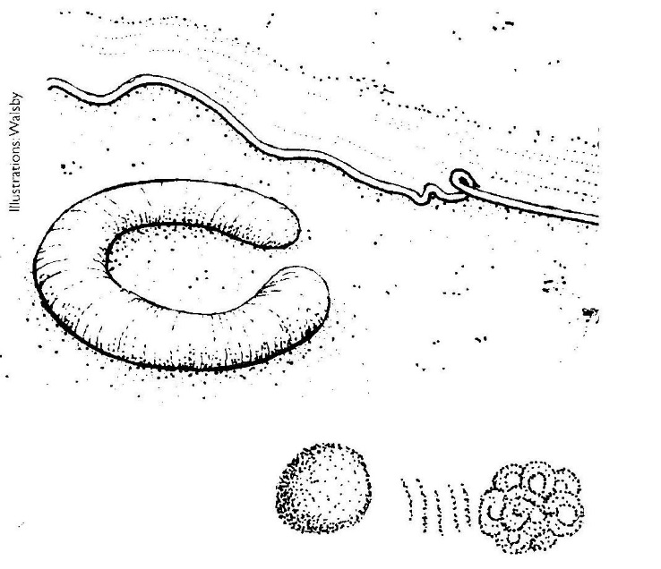

Look at these four signs left by some of the animals of the Inlet. 🢡

* Which animals do you think made them?
* What was each animal doing when it left its sign?
* Try to find these signs on the shore.

|  |  |
| --- | --- |
| Different kinds of birds have different kinds of feet. Gulls, shags and ducks have feet that help them swim. The webbing between ducks’ toes works rather like a kayak paddle, pushing water out of the way so they can go faster. Ducks’ feet also have no nerves, so they can’t feel the cold. Other birds, like herons and stilts, have feet that are good for walking and wading. | * What foot shape is good for swimming? * Why are herons’ feet different from ducks’ feet? * Why do stilts have long legs and gulls have short ones? |

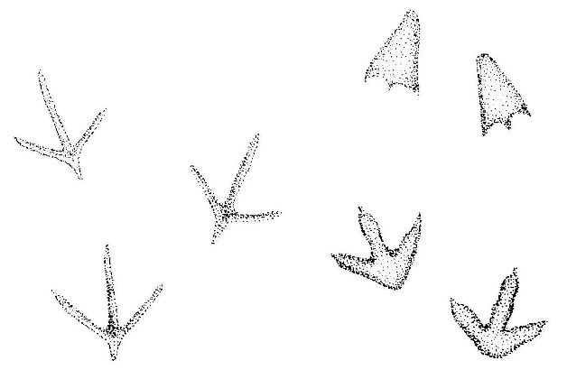

Look at these footprints made by three different birds. What can you tell about the birds from their footprints? Find and draw tracks left by different kinds of birds’ feet.

|  |  |  |  |
| --- | --- | --- | --- |
| Draw the track | Where did you find it? | What can you tell about the bird that made the track? | What bird do you think made the track? |