Something to do 8: comparing shellfish of the mudflats

At the estuary, you may find several different sorts of shellfish. Some of the common shellfish will be bivalves. This means they have two shells, which are ‘hinged’ together. You might find cockles, wedge shells, and pipi. Look at the three shellfish below.

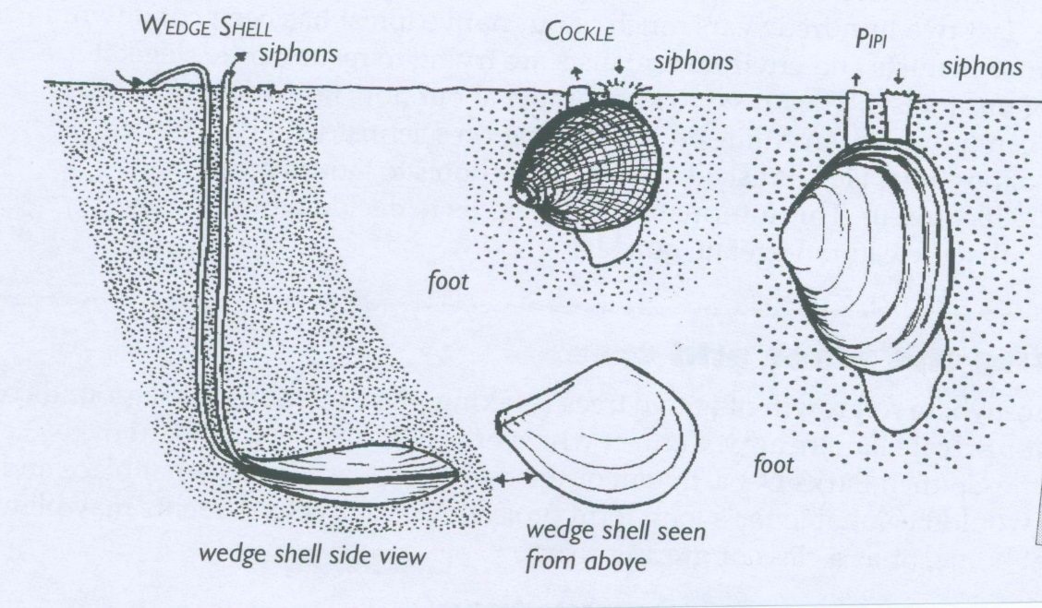

Answer the questions to show how these three animals are alike and different.

- What body parts do the cockle, the wedge shell and the pipi have in common?
- Where do the three shellfish usually live?
- How do they feed?
- What protects them while they are feeding?
- How deeply is each shellfish buried?
- Look at the shading around each animal. What does this shading tell you?

