Something to do 10: birdwatching

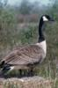  Canada goose | Go into one of the bird hides. Stay very quiet for ten minutes. Make a tally of the numbers of each species of bird you see. (The bird identification table at the back of this worksheet will help you recognise each bird.) |  | 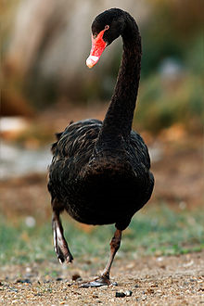  Black swan
Ducks
Canada geese
Black swans
While you are in the bird hide, choose one of the birds that you have observed. Write down everything you see. For example, is it eating? Is it alone or in a group? What does it look like? Does it land on the water or on land? When you get back to class, write a report for the local newspaper on your chosen bird or prepare a short talk to give to the class. |  | (Use the back of this sheet to write more)
Bird identification table

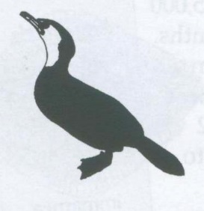 | Little shag  Kawaupaka | 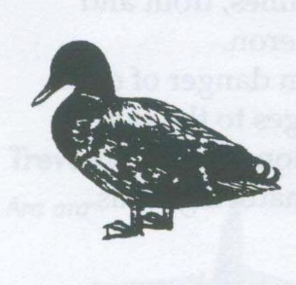 | Mallard
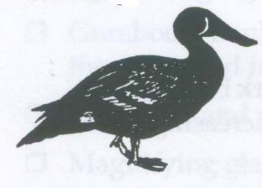 | New Zealand shoveler duck  Kuruwhengi | 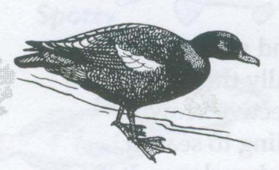 | Paradise shelduck  Putangitangi
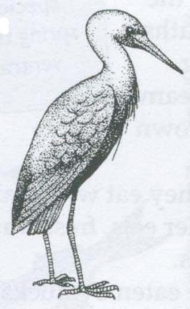 | White-faced heron | 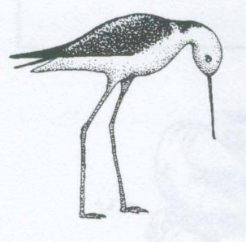 | Pied stilt  Poaka
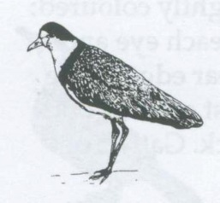 | Spur-winged plover | 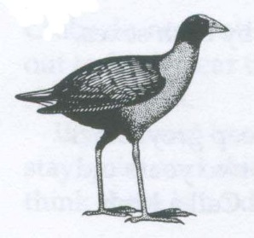 | Pukeko  Pukeko
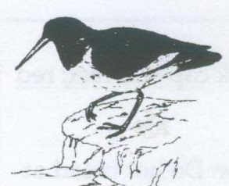 | Pied oyster catcher  Torea | 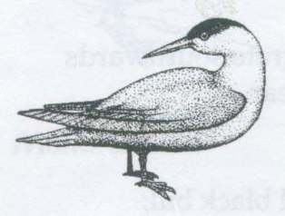 | Caspian tern  Taranui
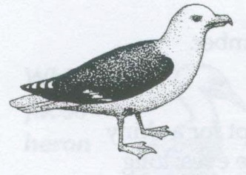 | Black-backed gull  Karoro | 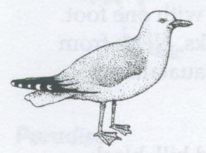 | Red-billed gull  Tarapunga

Illustrations from Owen/Crossland, Department of Education, Powell, Conservation NZ; previously published in Pauatahanui Inlet, a living resource, Guardians of Pauatahanui Inlet 1998.

