People of the Pauatahanui Inlet

Te Rangihaeata 1780 – 1855

Some very interesting people have lived around the Inlet in the past. One of them is the famous chief Te Rangihaeata. He was the nephew of Te Rauparaha, who is probably the best known of all the Maori chiefs in the Wellington district. Te Rangihaeata’s mother was Te Rauparaha’s sister.

Look carefully at these two old paintings of Te Rangihaeata. Write down five strong describing words that you think of when you see these paintings.

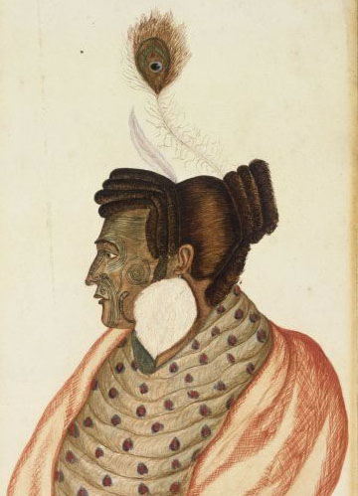  (Photos: above, Turnbull Library, artist R. Hall; right, The Fletcher Trust collection, artist Captain R.A. Oliver) | 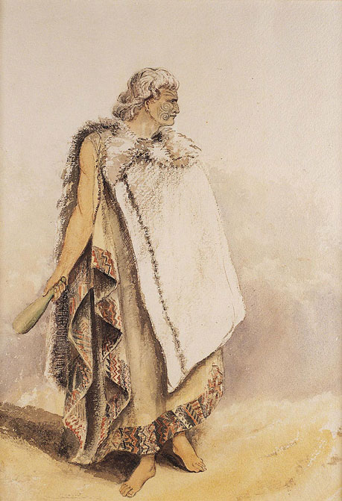

Now read these notes about Te Rangihaeata’s life.

Te Rangihaeata was born in 1780 in a place called Kawhia, which is in the Waikato. See if you can find it on a New Zealand map, and describe exactly where it is.

Te Rangihaeata belonged to the tribe called Ngati Toa. They were a fierce tribe who fought their way down the North Island trying to find somewhere to establish themselves. On their way south, they attacked tribes as they passed through Taranaki, Whanganui and Horowhenua. During this time Te Rangihaeata married one of the women whom he had taken prisoner. The tribe migrated down to the Kapiti coast and finally arrived at Porirua where Te Rangihaeata built several pa.

The tribe that was living here when Ngati Toa arrived was called Ngati Ira. They had lived in and around the Inlet since about 1600 but the Ngati Toa warriors drove them away from Porirua and the Inlet. Ngati Ira went over to the Wairarapa and resettled there.

Te Rangihaeata had very early contact and connections with Pakeha. By 1832 he was already trading with the European whalers who were working from Mana Island. When the New Zealand Company, represented by Colonel Wakefield, started buying up land so the English settlers could establish farms, Te Rangihaeata took part in the negotiations.

At first he was very happy to engage with Pakeha because he liked the trading and the exciting new things they brought with them. In 1840 he and Te Rauparaha signed the Treaty of Waitangi to say that they accepted English rule.

Soon, however, he realized that the new settlers were taking over the land and beginning to make their own rules. When the settlers in Porirua started to cause some trouble in 1842, Te Rangihaeata realized that he was beginning to dislike and distrust Pakeha.

The New Zealand Company was busy buying up large tracts of Maori land in various parts of the country and Te Rangihaeata was determined to stop this. He took a party of warriors over Cook Strait to Marlborough where Colonel Wakefield was surveying land he wanted to buy in Te Wairau, just out of Blenheim.

Te Rangihaeata tried at first to negotiate, but the story is that when it was dark, one of the Government soldiers got scared, perhaps thinking there was an animal nearby, and fired a shot which unfortunately killed Te Rangihaeata’s wife. Te Rangihaeata retaliated and a battle started. In the fight he took several prisoners and killed them to avenge his wife’s death. (In Maori, this kind of revenge is called utu.) One of the dead prisoners was Colonel Wakefield himself. The battle is known in the history books as the Wairau Massacre.

The governor of New Zealand, Governor Grey, became very concerned that Te Rangihaeata was getting too powerful and dangerous so he decided to try and restrain him. He sent troops to capture him, but the chief had built a strong pa at the head of the Pauatahanui Inlet on the hill where the old church stands today.  Why do you think Te Rangihaeata chose that place to build the pa? | 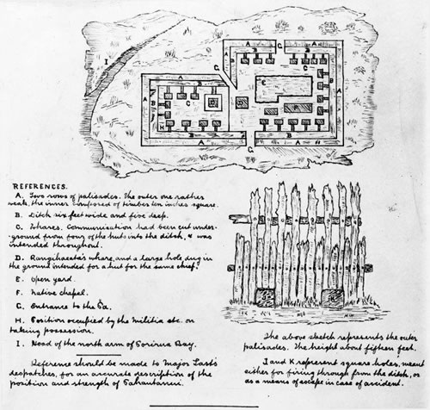  Ground plan of Te Rangihaeata’s pa at Pauatahanui (Alexander Turnbull Library)

At that time, before the 1855 earthquake, it is thought that the sea came right up to the bottom of the hill. Certainly the water was deep enough for ships’ boats, armed with a small cannon, to sail up the Inlet and land troops near the village. Other troops came over from the Hutt Valley to join the attack on the pa. (You will be able to read about the battle in the next unit.)

Te Rangihaeata knew that he had to get the children and old people away to protect them from the Government forces. By the time the soldiers arrived, he had already abandoned the pa and taken the tribe into the area known today as Battle Hill, not far up the Paekakariki Hill road. He took them to the top of the hill where he could easily see the approaching British soldiers. The British did not have enough food with them and were weighed down by their uniforms and guns, so after four days they had to retreat. Te Rangihaeata led his people over the hill to Poroutawhao, north of Levin. He lived there for the rest of his life and died in 1855 from pneumonia, which he got when he lay in a stream to try to get rid of a fever caused by measles.

He is remembered as one of the fiercest fighting chiefs, who strongly resisted the displacement of his people and their culture.

ACTIVITY 1

Look at the words which you wrote after viewing the paintings. Connect parts of Te Rangihaeata’s story to your words so that you can have a better understanding of the chief. For example, you might have thought that he looked proud or angry or aggressive or powerful. Are there parts of this story which show these qualities?

You might now want to add other words about him that the paintings did not show. Think about the quality he might have had which he showed when he led the old people and the children away from the fighting.

You can make a wordle using all your words if you like.

ACTIVITY 2

Trace or draw a map of New Zealand (or you can print one from the web). Track the migration that the tribe took when they moved south.

Make a key that shows the places Te Rangihaeata was born, died, built a pa and fought Colonel Wakefield.

ACTIVITY 3

Research Te Rangihaeata’s uncle Te Rauparaha. Find out at what points in his life he was working, living and /or fighting beside his nephew.

